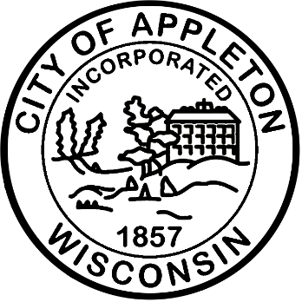
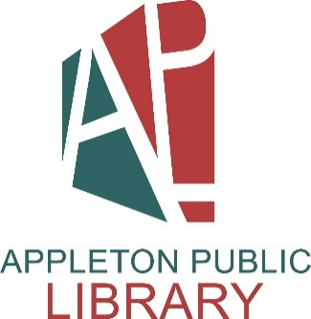

City of Appleton
Library Clerk (Half-Time)

The Appleton Public Library, the Wisconsin Library of the Year for 2025, is seeking a Library Clerk (Half-Time) to join our dynamic team.

The City of Appleton is seeking a Library Clerk (Half-Time). This is a non-exempt benefited position that involves working at a public service desk providing library services related to lending library materials, as well as performing off-desk tasks. Work is supervised by the Public Services Supervisor and a Public Services Assistant Supervisor.

Qualifications
This position requires a high school diploma or a combination of applicable experience and training is required.

Salary
The hiring range for this position is $18.08 - $21.70 hourly, plus an excellent fringe benefit package.

Apply Now!
If you are interested in applying for this position, please complete an on-line application at appletonwi.gov/careers by no later than Sunday, September 20, 2026. Resumes without an application will not be considered.

City of Appleton Human Resources
100 N. Appleton Street, 6th floor
Appleton, WI 54911
Phone: (920) 832-6458
Email: humanresources@appletonwi.gov
Equal Opportunity Employer

